WWI Study Guide
- European countries believed in Nationalism.
  - Nationalism is when a country thinks they deserve more success than other countries.
- Countries in Europe fought for land and power. To protect their land and power they made their armies very strong.
  - Militarism is when a country builds a strong army to scare other countries.
- European countries also made alliances with other countries.
  - An alliance is an agreement to support and defend each other; think of it as “having someone’s back.”
- The two major alliances were:
Allied Power Central Powers
1914 Austria declared war on Serbia
Serbia Austria-Hungary
Germany invaded both France and Belgium
Russia Germany
France
Russia was also fighting against Germany since France was a friend of Russia.
Belgium
Russia and Serbia were allies (friends) so Russia fought against Austria

- Soldiers were excited to fight in a war; they didn’t realize how tough it would be.
  - Trench warfare – The soldiers fought while standing in or lying down in narrow ditches called trenches. The soldiers basically lived in the trenches. It was very hard.
- Millions of soldiers were killed in the battles. The war lasted 4 years.

How did America get involved?
- President Woodrow Wilson wanted to stay out of the war saying “The United States must be neutral in thought as well as action.”

- In 1915, a German submarine sank the Lusitania, a British passenger ship with many Americans on board. Americans were angry after this.

- After the attack on the Lusitania, the Germans promised not attack any more passenger ships, but they broke that promise.

- In 1917 Germany began attacking U.S. ships. Soon after in April, 1917, the United States declared war on the Central Power alliance.

- American troops were in France by June 1917.

Weapons

- The Allies and the Central Powers had new weapons in WWI. They used machine guns that could fire hundreds of bullets per minute. They used hand grenades and fired cannons. Poison gas was also used by both sides. Later in the war, airplanes were used to drop bombs.

How did WWI change life in America?
- The war was great for the economy in America. Soldiers needed supplies like trucks, uniforms, masks, helmets, and weapons. During the war the U.S. was producing more war supplies than any country ever had before.
- Because the soldiers needed supplies, rations were placed on American civilians.
  - Rations are limits. Rations were placed on beef, sugar, and several other items. Civilians were only allowed a certain amount. What was not used was given to soldiers.
- Propaganda was used to remind Americans to help with the war effort.
  - Propaganda is information used to influence someone.

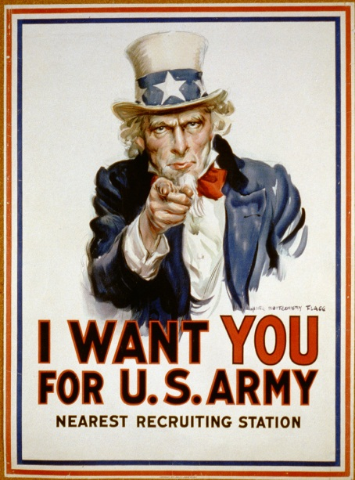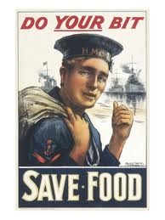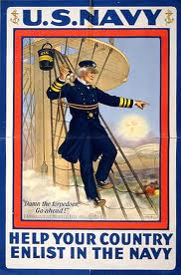

- During the war, thousands of African Americans left the South to work in northern cities where the factories were. Not only did they earn fair wages (money), but they also earned respect since they were helping our soldiers.

Women in the Workplace
- Since the men were off at war, this left opportunities for women to fill jobs that only men could typically do.
  - Women made weapons, repaired cars, delivered the mail, and directed traffic.
  - Society changed its opinion about women after seeing what they could do in the workplace.
- At this time only men had the right to vote (suffrage)
- In 1919, the Senate passed the Nineteenth Amendment to the Constitution. The states approved it in 1920; women could finally vote in the U.S.
The War Ends
- One million (1,000,000) soldiers went to France. This helped the Allies with important battles.
- The Central Powers realized that they could not win the war and signed an armistice.
  - An armistice is an agreement to stop fighting.
- The war ended on November 11, 1918.
The Treaty of Versailles
- President Woodrow Wilson joined the leaders of the Allied countries in France to write a treaty.
- The treaty was named after where it was signed, Versailles, France. It was a treaty to end the war.
- Germany was blamed most for the fighting in Western Europe.
- The treaty served as a punishment to Germany.
  - Germany lost colonies, land (given to France), and had to pay money to Allied countries.
- From the treaty came the League of Nations, a way to solve problems peacefully. Member of League of Nations promised to protect each other if another war was to start.
- The Senate refused to approve the Treaty of Versailles; they believed that it would cause the U.S. to be pulled into future wars. Many Americans agreed; they were horrified with the destruction of WWI.
  - This created isolationism (wanting to stay out of world events.)
- After WWI, the U.S. would avoid alliances and conflicts whenever it could.

